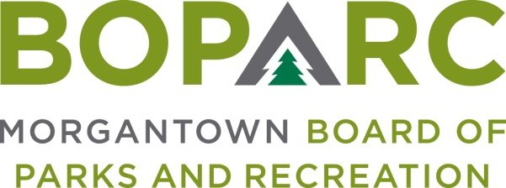

Wednesday, September 8, 2021 Time: 3:00PM Location: Marilla Center
799 East Brockway Ave.

AGENDA
OPENING MATTERS
- Call To Order
- Establish Quorum
- Minutes of August 11, 2021 Meeting

CORRESPONDENCE – Review of any pertinent correspondence since last meeting

ORAL COMMUNICATIONS
- Public Comment – Public Comment is intended to provide BOPARC an opportunity to receive information regarding items on the Agenda or other items of interest. Each comment is limited to three minutes. If there is multi-person interest in one subject, a single representative must be appointed to speak. There will be no official action taken on Public Comment (except in instances where the subject of interest is already an Action Item on the Agenda).

FINANCIAL REPORTS

EXECUTIVE DIRECTOR’S REPORT

OLD BUSINESS

NEW BUSINESS
- Sales Tax 20/21 2nd Iteration Projects

GENERAL BOARD COMMENTS

ADJOURNMENT

