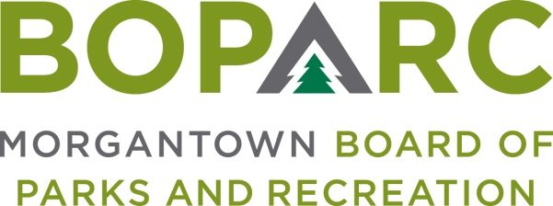

Wednesday, November 10, 2021 Time: 3:00PM Location: Marilla Center
799 East Brockway Ave.

AGENDA
OPENING MATTERS
- Call To Order
- Establish Quorum
- Minutes of October 13, 2021 Meeting

CORRESPONDENCE – Review of any pertinent correspondence since last meeting

ORAL COMMUNICATIONS
- Public Comment – Public Comment is intended to provide BOPARC an opportunity to receive information regarding items on the Agenda or other items of interest. Each comment is limited to three minutes. If there is multi-person interest in one subject, a single representative must be appointed to speak. There will be no official action taken on Public Comment (except in instances where the subject of interest is already an Action Item on the Agenda).

FINANCIAL REPORTS

EXECUTIVE DIRECTOR’S REPORT

OLD BUSINESS

NEW BUSINESS
- Health & Wellness Commission – Board Appointee Needed

GENERAL BOARD COMMENTS

ADJOURNMENT

*Please note – The City of Morgantown has instituted a mask mandate to attend City meetings. As BOPARC meetings are public meetings under the umbrella of inclusion as a City board or commission, masks will be required until further notice. As per the mandate, reasonable accommodations for anyone with a condition or disability that precludes them from wearing an adequate face covering can be arranged by contacting the City Clerk’s office at 304-284-7439.

