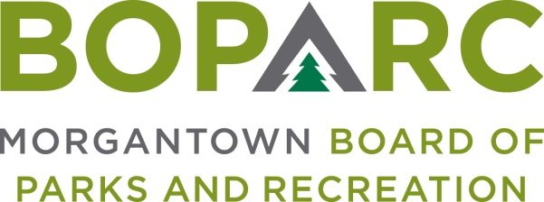

Wednesday, August 11, 2021 Time: 3:00PM Location: Wiles Hill Community Bldg.
287 Eureka Drive, Morgantown WV

AGENDA
OPENING MATTERS
- Call To Order
- Establish Quorum
- Minutes of July 14, 2021 Meeting

CORRESPONDENCE – Review of any pertinent correspondence since last meeting

ORAL COMMUNICATIONS
- Public Comment – Public Comment is intended to provide BOPARC an opportunity to receive information regarding items on the Agenda or other items of interest. Each comment is limited to three minutes. If there is multi-person interest in one subject, a single representative must be appointed to speak. There will be no official action taken on Public Comment (except in instances where the subject of interest is already an Action Item on the Agenda). For purposes of current virtual meeting protocol, public comment can be submitted prior to 12:00PM the day of the meeting to info@boparc.org.

FINANCIAL REPORTS

EXECUTIVE DIRECTOR’S REPORT

OLD BUSINESS

NEW BUSINESS
- Court Resurfacing Bid
- Budget Adjustments

EXECUTIVE SESSION - Acquisition or development of real estate at public parks. (It is anticipated that the board will discuss this matter in executive session as authorized by W. Va. Code 6-9A-4(b)(9) for matters relating to the acquisition or development of real estate)

GENERAL BOARD COMMENTS

ADJOURNMENT

