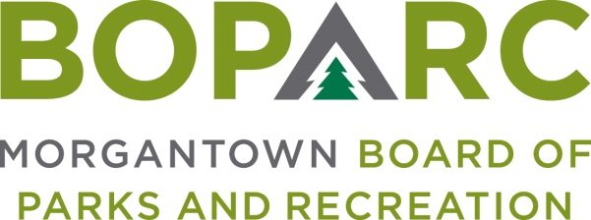

Wednesday, April 8, 2020 Time: 3:00PM Location: Marilla Center

AGENDA

OPENING MATTERS
- Call To Order
- Establish Quorum
- Minutes of February 12, 2020 Regular Meeting

CORRESPONDENCE – Review of any pertinent correspondence since last meeting

ORAL COMMUNICATIONS
- Presentation – Ryan Hess, Mills Group – LEED Certification
- Public Comment – Public Comment is intended to provide BOPARC an opportunity to receive information regarding items on the Agenda or other items of interest. Each comment is limited to three minutes (including questions from BOPARC). If there is multi-person interest in one subject, a single representative must be appointed to speak. There will be no official action taken on Public Comment (except in instances where the subject of interest is already an Action Item on the Agenda).

FINANCIAL REPORTS
- Profit/Loss
- Balance Sheet
- Budget v Actual

EXECUTIVE DIRECTOR’S REPORT

OLD BUSINESS
- LEED Certification Option – Ice Arena Project

NEW BUSINESS
- Softdrink Contract - Pepsi

BOARD COMMENTS

ADJOURNMENT

If you need an accommodation contact us at 304-284-7439.

